Sales Performance Analysis Project Report
Prepared By: Obaid Vadaliwala Tool Used: Google Sheets
Date: 23/02/2026

Introduction
This project analyzes two years of sales data to identify revenue trends, profitability drivers, regional performance, and the impact of discounts on overall business performance.

Dataset Description
The dataset contains 200 rows with the following columns:
  - OrderID – Unique order identifier
  - OrderDate – Date of purchase
  - Product – Product name
  - Category – Product category
  - Region – Sales region
  - Sales – Revenue generated
  - Cost – Cost of goods sold
  - Discount – Discount applied (%)
  - CustomerType – New or Returning customer
The dataset intentionally included missing values, duplicate records, and inconsistencies to simulate real-world business data.

Data Cleaning Process
- Removed duplicate rows using Google Sheets data cleanup tools.
- Handled missing Sales and Cost values using mean imputation.
- Replaced missing Discount values with 0 based on business logic.
- Created a Profit column (Sales – Cost).
- Extracted Month and Year from OrderDate for time-based analysis.
- Validated data types for numerical and date columns.

Key Performance Indicators (KPIs)
  - Total Revenue for 2 years : 81,04,567
  - Total Profit: 23,27,492.99
  - Profit Margin (%): 28.72%
  - Average Order Value: 42,655
  - Region-wise Revenue Contribution:
- West: 25.9%
- East: 21.6%
- North: 22.6%
- South: 29.9%
  - Top Performing Products:

Product | Sum of Sales
HeadPhones | 1345183
Keyboard | 1162631
Laptop | 1181538
Mobile | 1580824
Mouse | 1463263
Tablet | 1371128
  - Discount Impact on Profitability
High Discount and Low Discount Difference is around 6.8 % on average

Analysis Performed
  - Monthly Sales Trend Analysis to identify seasonality patterns. Highest Sales in March : 1,22,7662
Lowest Sales in December: 385707

Sum of Sales

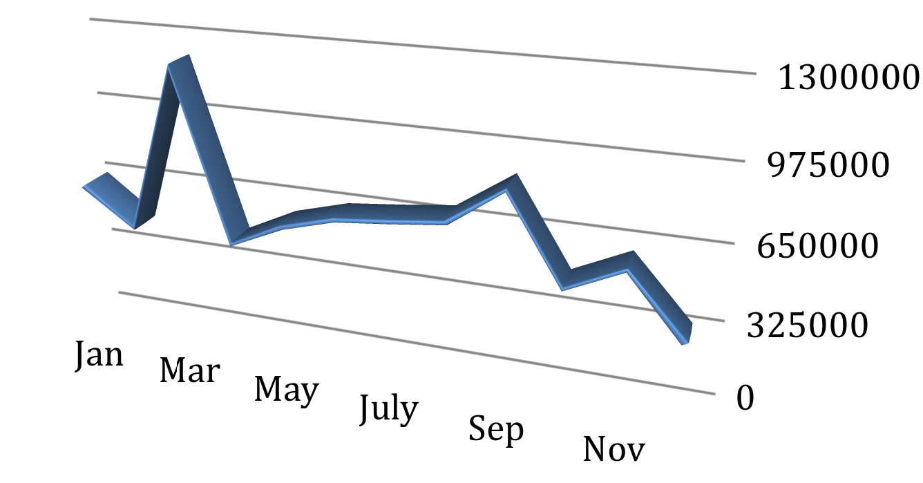

  - Product-wise Revenue Comparison to identify top-selling items. Highest Selling Product: Mobile, Sales: 1580824
Lowest Selling Product: Keyboard, Sales: 1162631

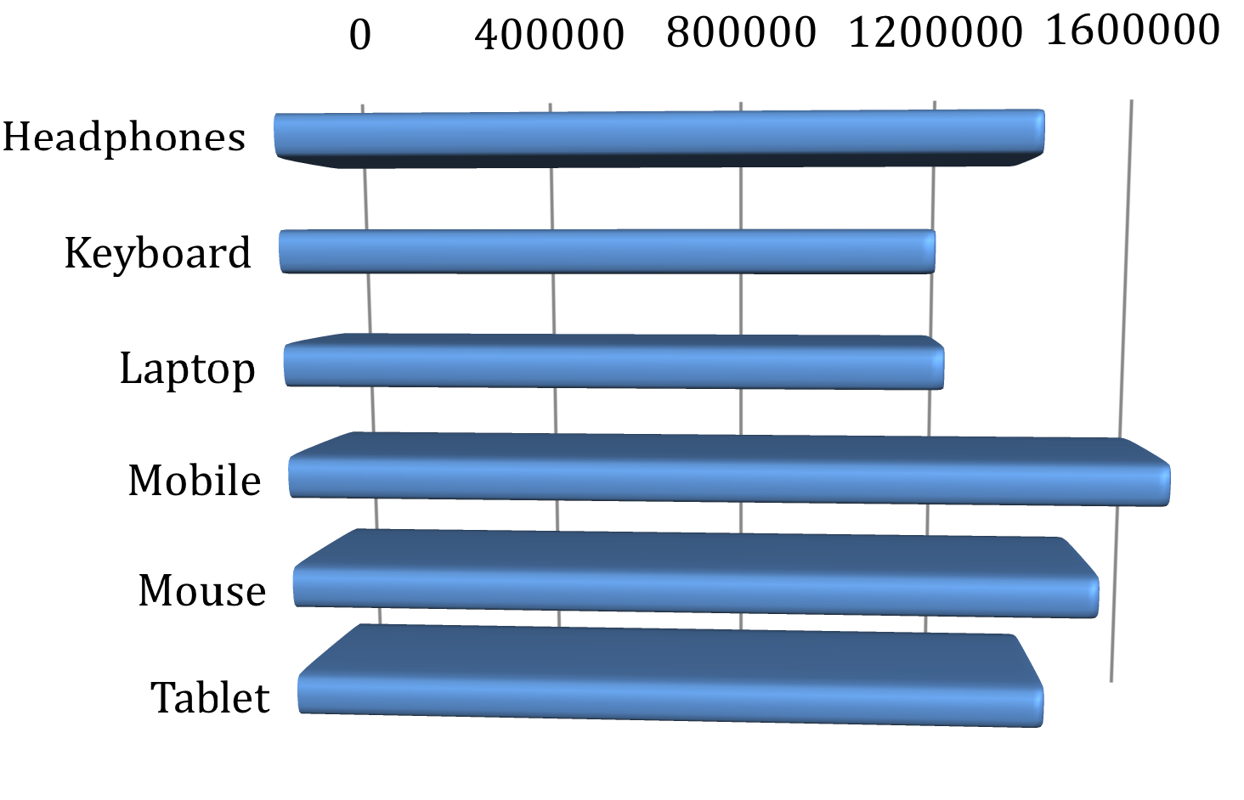
Sum of Sales

  - Region-wise Profitability Analysis. Region with Highest ProJit - South - 30% Region with lowest ProJit - East - 22%

 West  South  East  North

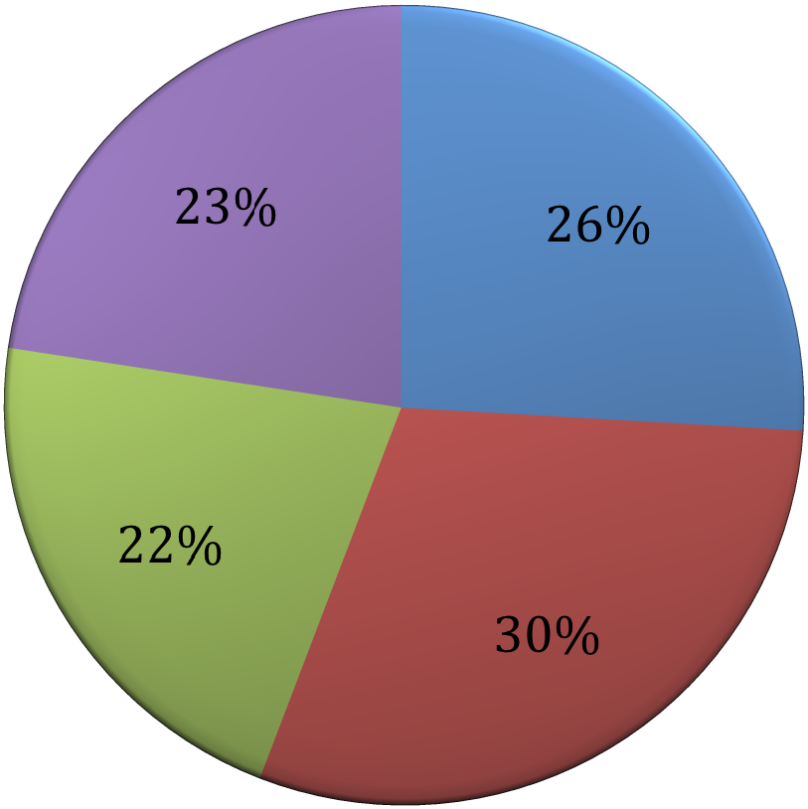

  - High vs Low Discount Impact Assessment.
Products having discount more than 20% are considered on Hight Discont

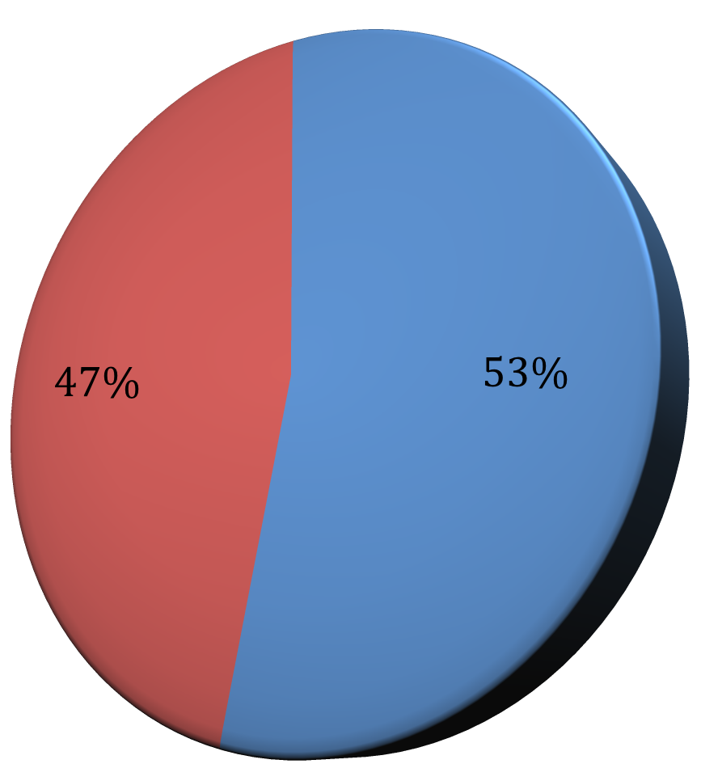 High Discount Low Discount

  - Customer Type Revenue Contribution Analysis. New - 56.19 %
Returning - 43.18%

Percentage of sales

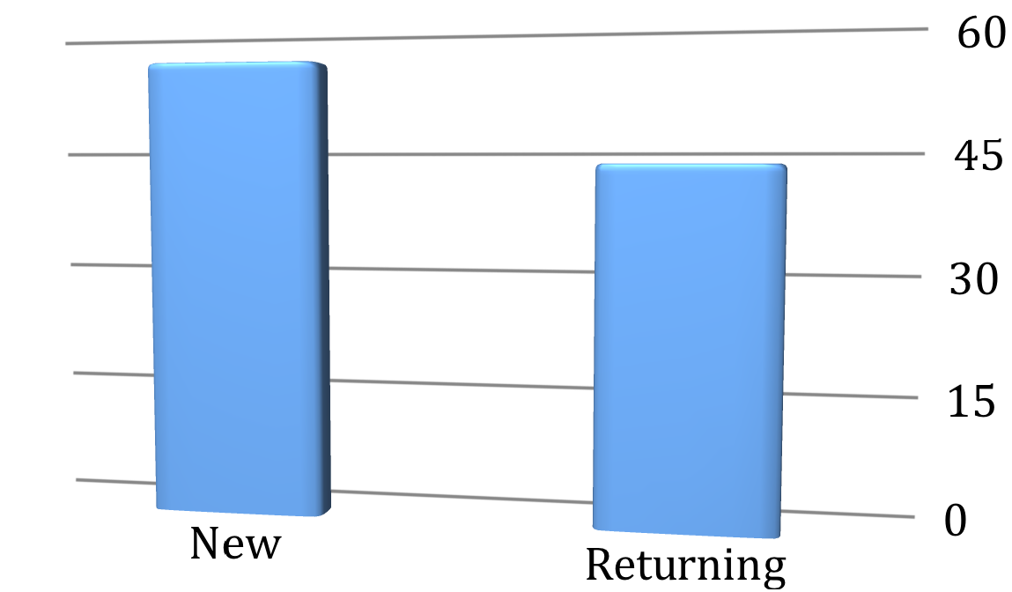

Key Insights
Example insights from the analysis:
  - Revenue peaked during festive months indicating seasonal demand.
  - Certain regions contributed high revenue but lower profit margins due to aggressive discounting.
  - Electronics category generated the highest revenue contribution.
  - Orders with discounts above 20% reduced overall profit margin significantly.
  - Returning customers contributed a substantial share of total revenue.

Business Recommendations
  - Optimize discount strategy to maintain healthy profit margins.
  - Focus marketing campaigns on high-performing regions.
  - Improve inventory planning for top-selling products.
  - Strengthen customer retention strategies to increase repeat purchases.

Conclusion
This project demonstrates strong data cleaning, analytical thinking, KPI building, and dashboard development skills using Google Sheets. The insights derived can help management make data-driven decisions to improve proJitability and operational efJiciency.

